### 12th February 2016

### YOKOHAMA to expand high-performance tyre production capacity at Shinshiro Plant

Tokyo–The Yokohama Rubber Co., Ltd., announced today that it plans to expand its Shinshiro Plant (in Shinshiro City, Aichi Prefecture) to increase production capacity for high-performance tyres (18” diameter and larger). The Company plans to begin construction of a new line this May and start production in June 2017, gradually increasing output until reaching full capacity by April 2018. Total investment will be about Yen 3.7 billion. The capacity expansion will increase the Shinshiro Plant’s annual production capacity for high-performance tyres (18” diameter and larger) by about 20% from the current level.

Large tyres provide exceptional vehicle manoeuvrability and a stylish appearance. Consequently, they are often adopted by the world’s leading automakers as original equipment on luxury sports cars and SUVs, which have become popular around the world. In addition, global replacement market demand for large tyres is increasing. YOKOHAMA has developed a wide range of large passenger-car tyres line-up for both the original equipment and replacement markets. These tyres are highly profitable and demand is growing more than ever, so the Company has decided to invest to expand its production capacity for these larger sizes.

The Shinshiro Plant has the largest annual production capacity for passenger car tyres of any plant in the YOKOHAMA group. The Shinshiro Plant and nearby Shinshiro-Minami Plant can produce a combined total of 16.9 million tyres a year (as of December 2015).

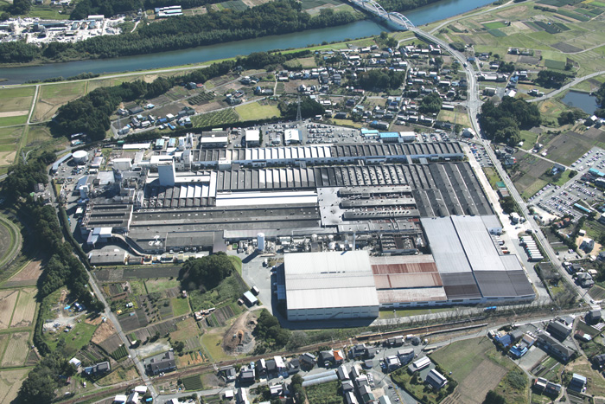

*Shinshiro passenger-car tyre plant*

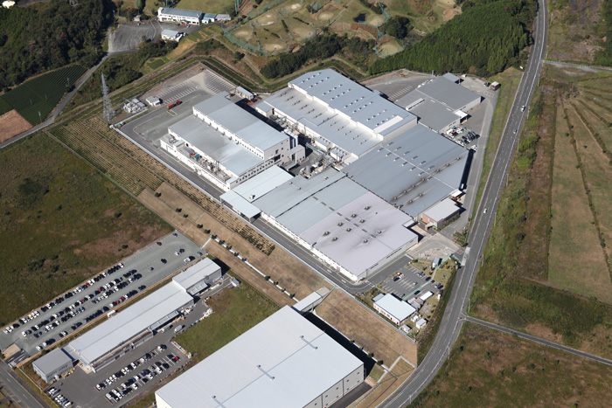

*Shinshiro-Minami passenger-car tyre plant*